Task 3 : To create lists like this.

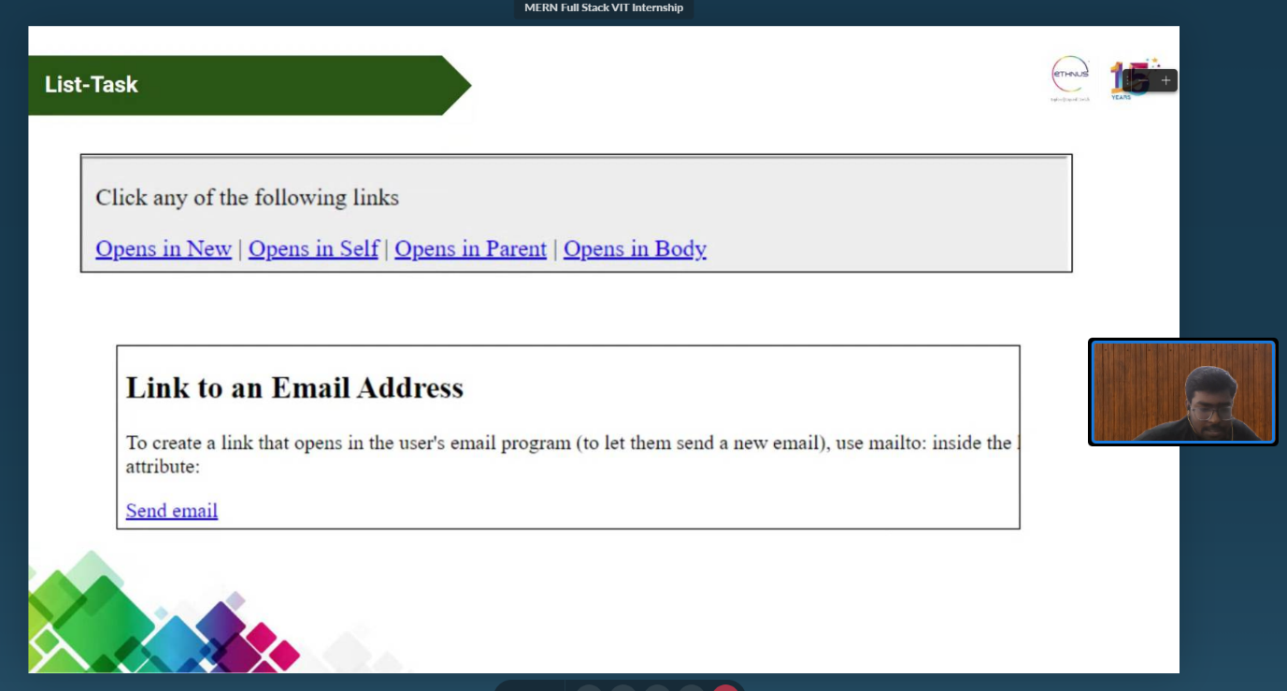

HTML code:

<html lang="en">

  <head>

    <meta charset="UTF-8" />

    <meta http-equiv="X-UA-Compatible" content="IE=edge" />

    <meta name="viewport" content="width=device-width, initial-scale=1.0" />

    <title>List Task</title>

  </head>

  <body>

    <br />Lists - 20BCE2096 <br /><br /><br />

    <ul style="list-style-type: none ; display: flex; justify-content: space-around; max-width: 450px;">

      <li><a href="https://google.com" target="_blank">Open in new</a></li>

      <li><a href="https://google.com" target="_self">Open in self</a></li>

      <li><a href="https://google.com" target="_parent">Open in parent</a></li>

      <li><a href="https://google.com" target="_top">Open in body</a></li>

    </ul>

    <div>

      <h1>Link to email address</h1>

      <p>

        To create a link that open's into user's email program (to let them send

        a new email ), use mailto attribute

      </p>

      <a href="mailto:tejas292002@gmail.com">Send Email</a>

    </div>

  </body>

</html>

Output:

